

## Topic: Submitting Feedback in theSource

Do you have valuable feedback you would like to provide on a document in theSource? Use the Message icon  within the document (lower left corner) to send it!

Once your feedback is received, it will be relayed to the appropriate individual for review. You may receive an email if additional information is needed and/or a confirmation of your submission.

Follow the steps below to send your feedback:

1. Click on the Message icon.
2. Choose the “**It needs improvement**” radio button in the “Compose Feedback” panel.
   * If you only want to provide positive feedback, choose “**It’s good!**.” This is not used to acknowledge that you have read the document.
3. Select the appropriate option from the list to classify the nature of your feedback. You may choose more than one, if needed.
4. Type in the details of your feedback in the “**Tell Us More**” section.
5. Click Send.

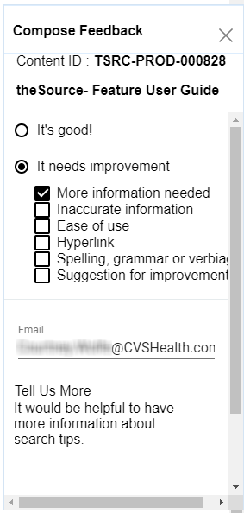

**Result:**  The below confirmation will display.



For additional information about submitting feedback, refer to: [Submitting Feedback in theSource Job Aid](C:\\Users\\NChristian\\Downloads\\TSRC-PROD-020332). If you have feedback regarding a CIF, check out [Submitting Feedback and Reporting Client Issues.](C:\\Users\\NChristian\\Downloads\\TSRC-PROD-002194)

 Here is your next challenge on the quest to becoming a Certified theSource Wizard:

* The next time you encounter a document that could be improved, submit feedback in theSource.
* Be as detailed as possible so the appropriate action can be taken on your feedback.
* **Remember:**  Do NOT include any member information (PHI/PII).